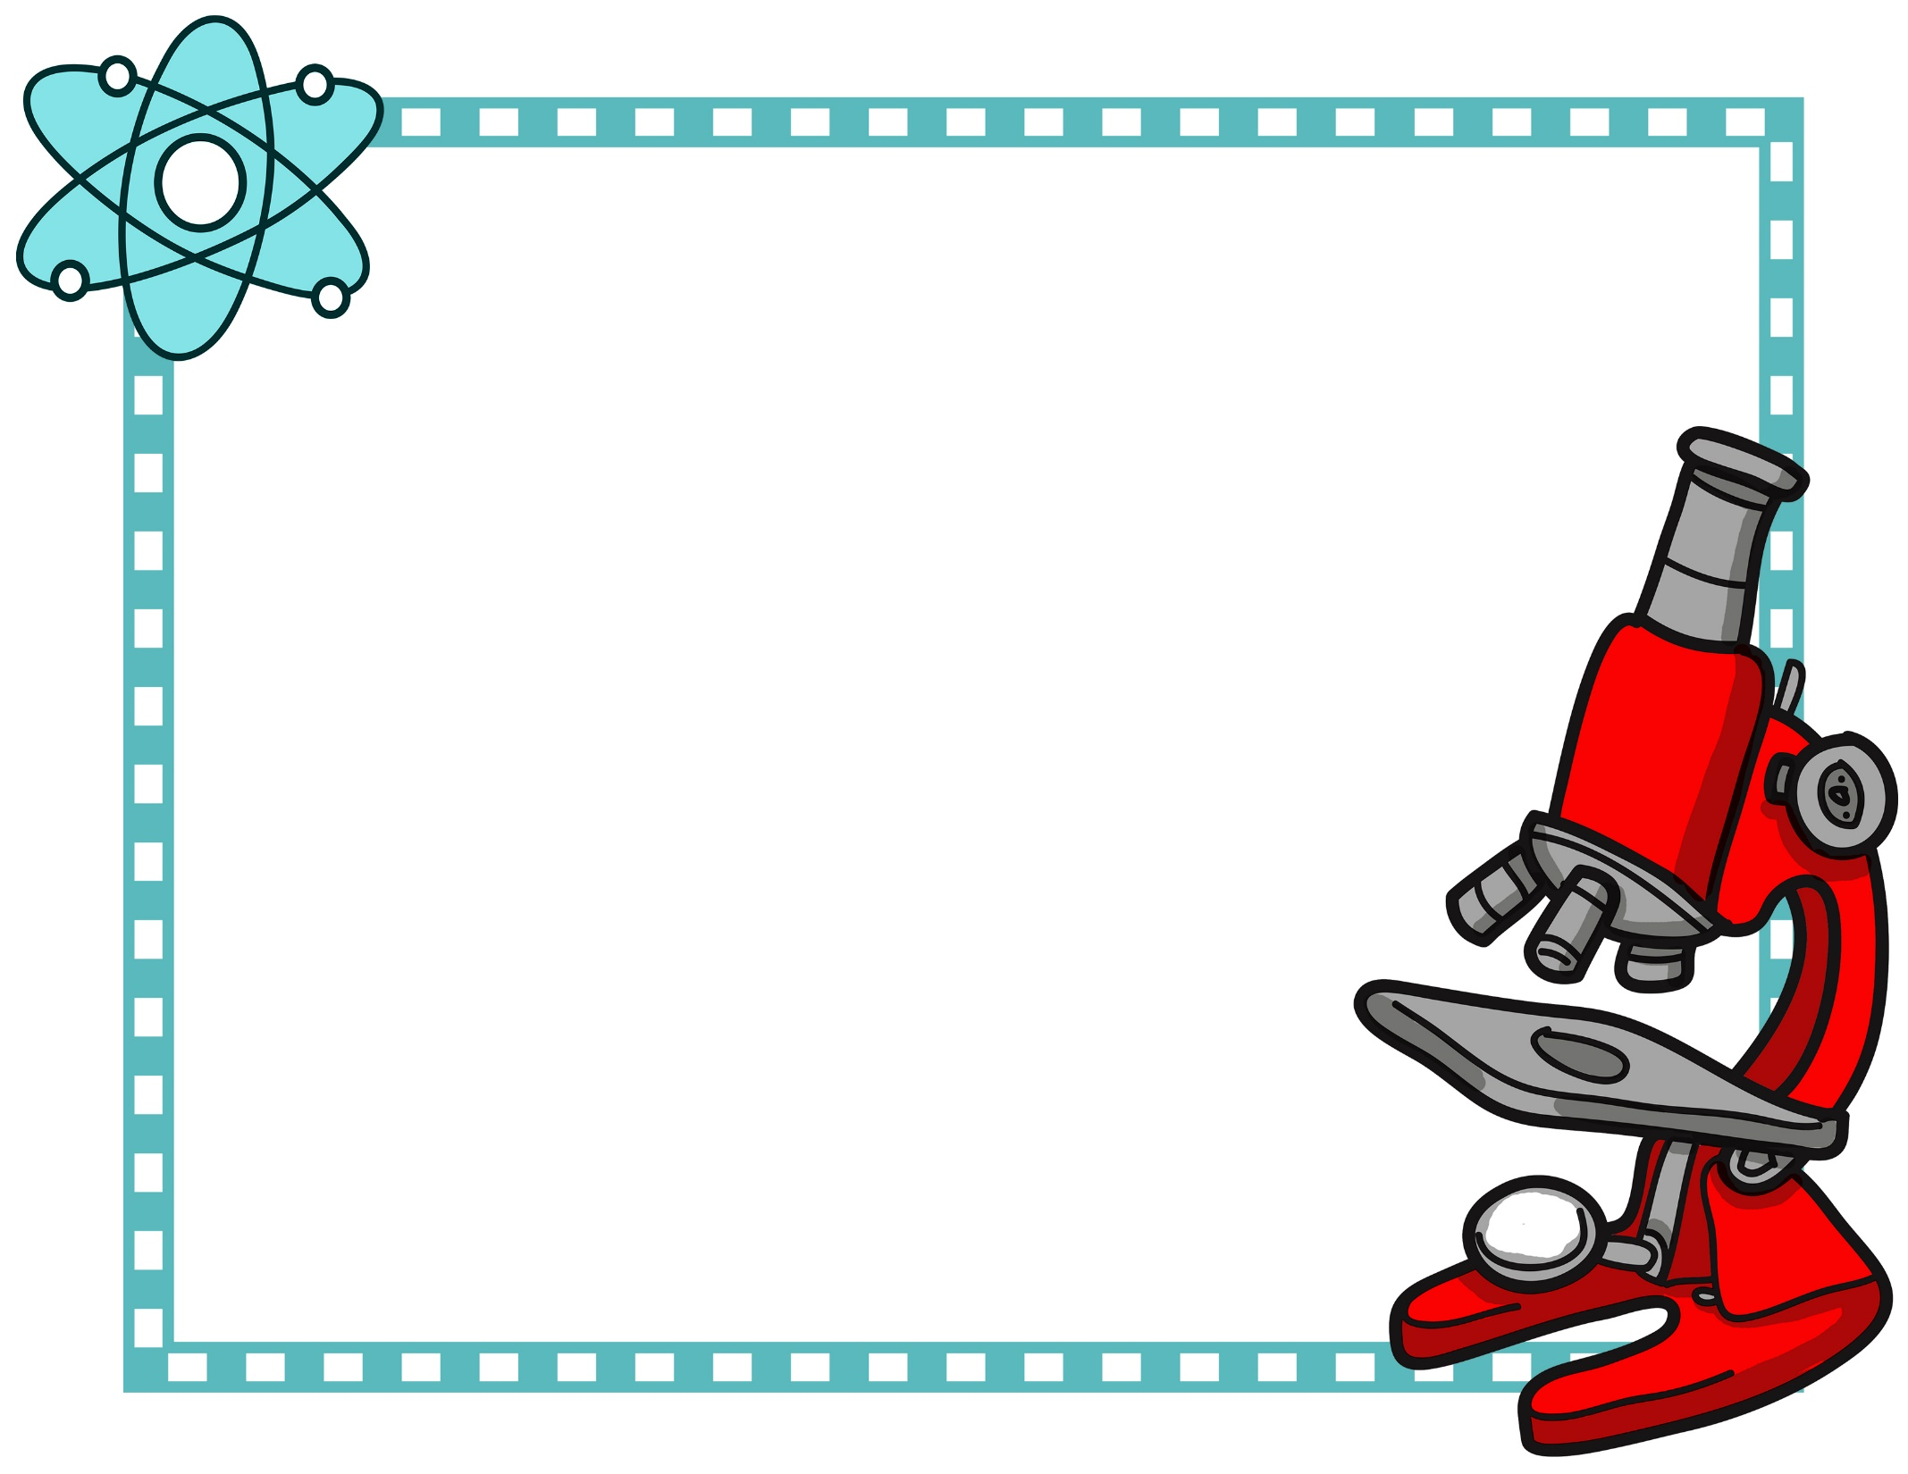

**Awesome Job!**

_______________

Mrs. Dickson   
STEM Mentor

This certificate is presented to

_____________________

for completing the

Snow Scoop  
 Challenge

December & January STEM Challenge